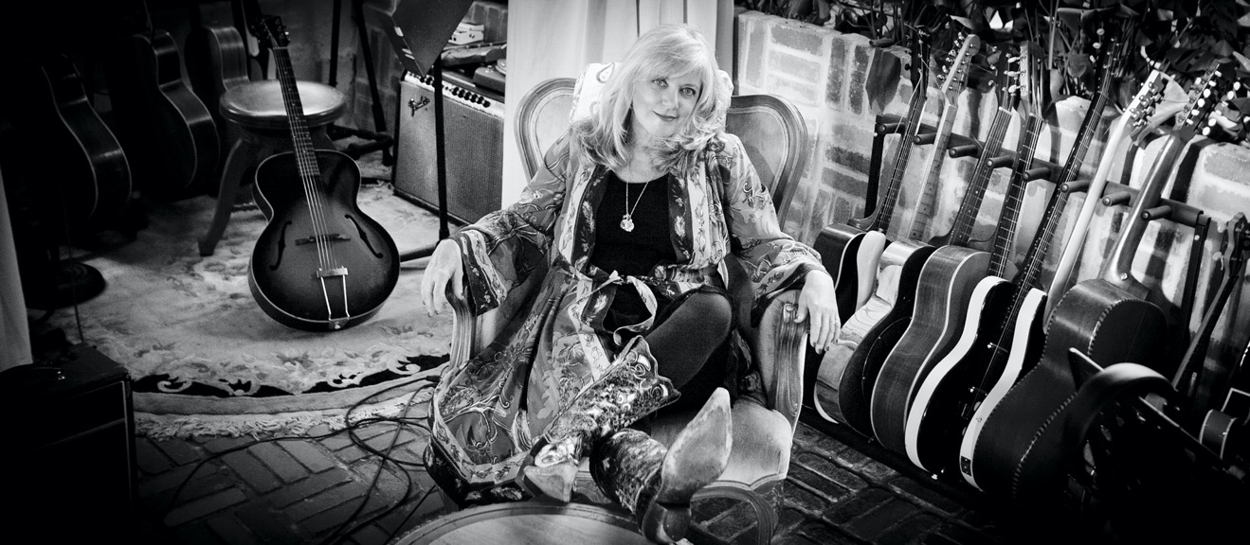
“Kimmie Rhodes: The soul of a poet and the voice of an angel.”
– Rodney Crowell

Kimmie Rhodes

Singer/Songwriter • Recording Artist • Culinarian • Storyteller
• Ambassador • Speaker
The Austin Chronicle calls Kimmie Rhodes is a “prolific figure in Texas Music.” The Austin-based singer-songwriter has released 16 solo albums; written and produced three musical plays; published a novella/cookbook and a memoir. She blends these unique skills and captivates audiences on stages around the world, and in intimate group settings. A native Texan, she was raised in Lubbock, where she cultivated the spirited mix of talent and determination that still fuels her success. Kimmie was inducted into The West Texas Walk Of Fame for her "outstanding contributions in the field of art music and entertainment" on September 28, 2023.
While the term is often overused, a “songwriter’s songwriter” truly describes Kimmie, as is evidenced by people who have sought her out to co-write with her and recorded her songs. She has written many multi-platinum songs, recorded by such stellar artists as Willie Nelson, Wynonna Judd, Trisha Yearwood, Amy Grant, CeCe Winans, Joe Ely, Waylon Jennings, Peter Frampton, Mark Knopfler, Emmylou Harris, and others.

In 1981, she recorded her first album, Kimmie Rhodes and the Jackalope Brothers when Willie Nelson invited her to use his studio. In 1985, she recorded her second album, Man in the Moon. Her third album, Angels Get the Blues, recorded at the original Sun Studio in Memphis, was released in 1989. These records led to a series of British and European tours that received rave reviews.

Kimmie's promotional tours have created a solid fan base in the U.K., Ireland, and across Europe. She has headlined with her band at festivals all over the world and has appeared on many European and American TV and radio broadcasts. She has also appeared at many of Willie’s Farm Aid concerts and 4th of July Picnics. Willie dubbed Kimmie “an undiscovered superstar” and together they recorded two of her originals for his album, Just One Love, and a duet album, Picture in a Frame.

Kimmie’s lengthy discography looks like a who’s who of American musicians and songwriters, featuring duets with Willie Nelson, Emmylou Harris, Joe Ely, Tom Petty, Gillian Welch and David Rawlings among others, and includes co-writes with Willie Nelson, Emmylou Harris, Waylon Jennings. Beth Nielson-Chapman, and more.

Kimmie appeared on Austin City Limits with Emmylou Harris, Dave Mathews, Patty Griffin, and Buddy & Julie Miller, where she and Emmylou performed their song “Ordinary Heart.” She guested on Late Night with David Letterman, performing “West Texas Heaven” at his request. Kimmie’s TV appearances also include a songwriter “guitar pull” Austin City Limits show with Willie Nelson, Waylon Jennings, Kris Kristofferson, and Billy Joe Shaver; two segments of The Nashville Network’s Legend Series hosted by Willie Nelson, and another segment hosted by Waylon Jennings.
Kimmie has the voice of a beautiful child coming from an old soul. She touches us where the better angels of our nature dwell, and I believe we need that now more than ever. If you haven’t before, do yourself a favor and bring her into your listening life.”
–Emmylou Harris

Waylon said, “When I hear Kimmie sing it makes me know what the phrase ‘pulling on your heart strings’ means.” Kimmie co-wrote “Lines,” with Waylon for his Justice release, Right for The Time. At her own Sunbird Studios, Rhodes has hosted some of the Austin’s finest singer-songwriters to film a segment of Bob Harris' iconic Back To series for WBBC-TV.

Kimmie’s movie soundtrack credits include “A Heart That’s True” for the Babe: A Pig in the City album; “I’m Not An Angel” featured in the soundtrack of Mrs. Winterbourne; and a song in the Daddy’s Dyin’ Who’s Got the Will soundtrack. Her song “Shine All Your Light,” co-written with Beth Nielsen Chapman, was recorded by Amy Grant for the Touched by an Angel TV series soundtrack and album release, which reached the Top Ten in Billboard’s charts. Kimmie co-wrote “Ordinary Heart” with Emmylou Harris, which was featured in the soundtrack to the movie, Happy Texas. Emmylou’s performance of the song was nominated for a Grammy®.

Kimmie’s 1996 album, “West Texas Heaven” features twelve of her original songs and includes duets with Waylon Jennings, Townes Van Zandt, and Willie Nelson. USA Today said, “listening to West Texas Heaven is like a sweet unhurried ramble through bluebonnets,” picking the album for their “Best Bets” section. USA Today later picked the album as one of the “Top Ten Country Records” of that year.
In 2013, in a rare moment for the well-known songwriter, Kimmie released an album covering some of her favorite songs, entitled Kimmie Rhodes Covers. Covers marked a “sea change” for Kimmie Rhodes. Kimmie draws deep from a wide range of catalogues - Thiele and Weiss, Lennon and McCartney, Jagger and Richards, Jimmy Reed, Mark Knopfler, Dylan, Bono, Tom Petty, Leon Russell, Neil Young and Tom Waits, and channels close friends Townes Van Zandt and Rodney Crowell; telling each story in that clear, soaring songbird voice that takes ownership of every composition.

Another album of all original songs titled Cowgirl Boudoir was well received when it was released in the spring of 2015. The Sunbird Studios House Band delivered a mélange of steel guitar, dobro, ukulele, mandolin, electric sitar, B3 organ and percussions that underscored this edgy musical autobiography with “cowpunkadelical” perfection.

A playwright and actress as well, Kimmie’s debut theatrical project was her musical, Small Town Girl, directed by and starring Joe Sears of Greater Tuna. She also released an album by that title of the music featured in the play. Riding on the success of that project, she and Sears then wrote and produced a musical revue, Hillbilly Heaven. She worked with Sears as Musical Director for his outdoor drama production of Trail of Tears for the Cherokee Heritage Center from 2001 through 2003.

Kimmie is an honorary ambassador for The Buddy Holly Educational Foundation. Based in England, the international foundation’s mission is to honor Buddy’s legacy as well as to fulfill Buddy and Maria Elena Holly’s dream of extending musical education including songwriting, production, arrangements, orchestration, and performance to new generations regardless of income, ethnicity or learning levels.
"(Kimmie is) a highly respected and much-loved artist/ song-writer hailing from Buddy's birthplace, Lubbock, Texas.
It gives me great pleasure that she has one of our unique guitars titled "Lonesome Tears" and has joined our close-knit family as an Ambassador of
The Buddy Holly Educational Foundation."
- Maria Elena Holly

Kimmie visits Glastonbury, England annually to attend Squeeze co-founder Chris Difford’s songwriting retreat at Pennard House, where established singer-songwriters share knowledge and co-write with aspiring young talents. Foundation co-founders and Holly’s widow, Maria Elena Holly, celebrated Rhodes’ efforts by presenting her with a custom-made guitar crafted by famed luthier Alistair Atkin. A replica of Buddy Holly’s 1943 J-45, the guitar is encased in hand-tooled leather. Fellow ambassadors with whom Rhodes shares this special honor, each presented with a uniquely titled guitar, include Paul McCartney, Keith Richards, Pete Townshend, Brian Wilson, Dolly Parton, and Bob Dylan.
The Future
Kimmie’s newest album “Hypnotized” of all original songs, recorded at her own Sunbird Studios is scheduled for full release on March 29, 2024 – preceded by a “waterfall” of releases beginning on January 26 with the title track “Hypnotized.” She has dates planned in the US and also UK and Ireland to promote the new album. Details on show can be found on the events page: https://kimmierhodes.com/events/
Links to the new digital release can be found here: > https://kimmierhodes.com/events/

The Austin Chronicle calls Kimmie Rhodes “a prolific fixture in Texas music.” Today, she continues to make her home in the Texas hill country outside of Austin and is working on a new book with the working title “Eat or Die,” which, in her signature humorous style, offers gourmet reminiscences and recipes gleaned from her intrepid life as a touring artist and all around “foodie.”
She has developed a songwriting-storyteller show which includes a reprise of some of her best work along with some new material that opened in the fall of 2022. She has locked in some exclusive shows including a cruise, conferences, and festivals; as well as a limited number of her very successful “special event house concerts.”
Kimmie spends several months each year in her second home in the South of France, writing and performing – and making plans for “what happens next.”
Kimmie is currently serving the Austin music community as an advisory board member for HOME (Housing Opportunities for Musicians and Entertainers) in order to help raise funds and awareness to ensure that Austin's elderly musician veterans have secure housing.

For more details, please read the Kimmie Rhodes Full Length Bio.

