“I solicit presenters for various educational, cultural, and social organizations and have
heard Kimmie Rhodes perform in several settings, telling her story, playing guitar and
singing her compositions in her wonderfully soulful and melodious voice, bringing
her audience to their feet with standing ovations.”
- Karen Haschke - Austin Women’s Club

Kimmie Rhodes
Singer/Songwriter • Culinarian • Storyteller • Ambassador • Speaker
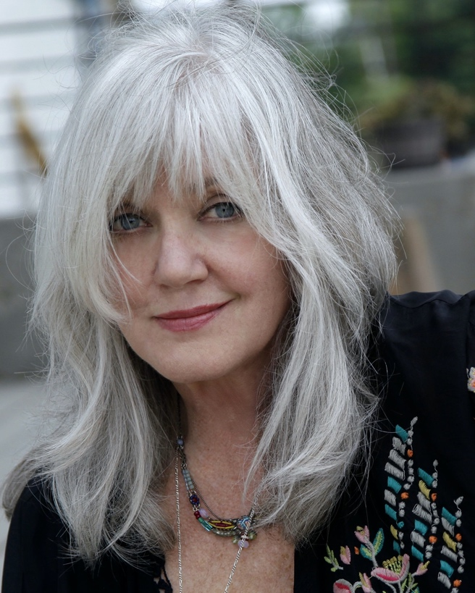
Kimmie Rhodes is a Modern Renaissance Woman. She has a proven array of skills and expertise, from chart-topping songwriting to gourmet cooking, from playwright to humorist, documentarian to ambassador, and more. She blends these unique skills and captivates audiences on stages around the world, and in intimate group settings. A native Texan born in Lubbock, she has cultivated the spirited mix of talent and determination that still fuels her success.
The Austin Chronicle calls Kimmie “a prolific fixture in Texas music.” She enchants crowds with tales and songs related to her songwriting and performance, her collaborations with A-listers including Willie Nelson, Emmylou Harris and Waylon Jennings, to name a few, along with stories of 30+ years on the road.
On a more serious side, Kimmie intertwines her songs with positive messages of compassion, resilience, and strength, of coming back, bouncing forward and finding happiness in the aftermath of tragedy and devastation. She has been the caregiver for a husband who died with cancer, a mother with dementia, and a newlywed daughter who lost her husband in a motorcycle accident, and has found her way back into the light, leading others in finding the magic in everyday life.
Kimmie’s following continues to grow as audiences of all ages enjoy her speaking/singing engagements at bookstores, university forums and graduate classes, with culinary courses for world class spas, gourmet grocers, and small group private lessons, on cruises and in intimate listening venues, and of course at her own concerts across the USA and Europe.
Kimmie has the voice of a beautiful child coming from an old soul. She touches us where the better angels of our nature dwell, and I believe we need that now more than ever. If you haven’t before, do yourself a favor and bring her into your listening life.”
–Emmylou Harris
The acclaimed singer-songwriter has released 16 solo albums; written and produced three musical plays; published a novella/cookbook and a memoir; and written many multi-platinum songs, recorded by such stellar artists as Willie Nelson, Wynonna Judd, Trisha Yearwood, Amy Grant, CeCe Winans, Joe Ely, Waylon Jennings, Peter Frampton, Mark Knopfler, Emmylou Harris, and others.
Kimmie has written two popular books, The Amazing Afterlife of Zimmerman Fees (Sunbird Press), a whimsical fantasy combining her knowledge of travel and cuisine with a generous serving of humor. Some of Kimmie’s most requested recipes are included in the book, making it a standard on collectors’ cookbook shelves.
Radio Dreams: The Story of the Outlaw DJ and the Cosmic Cowgirl, a "duet memoir" that weaves her own poetic prose with wry and witty posthumous musings from her late husband, iconic radio personality Joe Gracey. Released in the Spring of 2018, Radio Dreams invites readers into their private world, returning Joe to the conversation to help tell the fascinating story of their lives.
Her trippy songwriter tales and his alternately hilarious and poignant writings take readers on a time-machine adventure, from Saturday mornings spent watching country-and-western TV stars to the wild ‘70s era in which hippies kick back with rednecks to enjoy the music in the “Groover’s Paradise” of Austin, Texas.
Kimmie is an honorary ambassador for The Buddy Holly Educational Foundation. Based in England, the international foundation’s mission is to honor Buddy’s legacy as well as to fulfill Buddy and Maria Elena Holly’s dream of extending musical education including songwriting, production, arrangements, orchestration, and performance to new generations regardless of income, ethnicity or learning levels.
"(Kimmie is) a highly respected and much-loved artist/ song-writer hailing from Buddy's birthplace, Lubbock, Texas.
It gives me great pleasure that she has one of our unique guitars titled "Lonesome Tears" and has joined our close-knit family as an Ambassador of
The Buddy Holly Educational Foundation."
- Maria Elena Holly

Today, Kimmie continues to make her home in the Texas hill country outside of Austin and is working on a new food memoir with the working title “Eat or Die,” which, in her signature humorous style, offers gourmet reminiscences and recipes gleaned from her intrepid life as a touring artist and all around “foodie.”
Her latest songwriting-storyteller revival has a theatrical flair and includes a reprise of some of her best work along with some new material. It will open in the fall of 2022. Kimmie is also writing and finalizing pre-production plans for a new album of all original songs to be recorded at her own Sunbird Studios this summer for a future release and has just released a commemorative vinyl of her duet record with Willie Nelson, Picture in A Frame.
Kimmie spends several months each year in her second home in the South of France, writing and performing – and making plans for “what happens next.”

For more details, please read the Kimmie Rhodes Full Length Bio.

